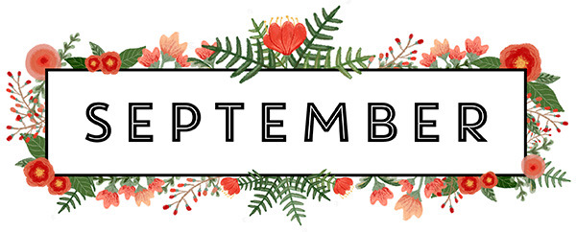
Newsletter 2017
We want to wish all of our school leavers all the best in their next adventures. We are all very sad to see them go but know they are all ready to be big boys and girls. We would like to welcome all of our new children and families to Parrock House, we hope you are all happy with the care you receive whilst here at nursery.
We would like to let you know of some staff changes in September. We are really looking forward to welcoming back Emma Jeffrey who has been off during the six weeks holidays. We wanted to let you know Emma will be returning as our senior team member in the baby room. Emma has had lots of experience with our younger children and is excited to be back working alongside Julie, getting to know all parents and families again. We are also really excited that Aisha will be moving to our preschool room looking after our oldest children. Aisha will be sad to leave the baby room but is looking forward to a new challenge.
We are currently in the process of updating our face book page; we intend to use the page to share information such as upcoming events, newsletters and photo’s of the children. Please like and share our page to see what fun and exciting things we will be getting up to.
We have some new I’d love to tell you cards that we would like to introduce for all rooms. They will be available for you to take one home and write about any news you have, holidays or anything exciting the children have been doing at home. Please give them to your key worker so that they can add them to your Childs learning journals and talk about or expand the activity at nursery.
Over the next few months we will be organising some different visitors to come to nursery. In October we have pets at home visiting with different animals and we have also contacted the local fire brigade to join us. If any parents have an interesting job and like to come in to speak to the children about what they do, Please let a team member know as we would love you to join us for an exciting session.
If you have any questions about the above please do not hesitate to speak to a member of the management team.
Many thanks
All staff at Parrock House Nursery.
Babies
This month our babies have had lots of fun doing lots of creative activities. They have particularly enjoyed various mark making activities, they have created gloup using corn flour and water, shaving foam and also mark making with paint. They have enjoyed exploring the sensory area looking at different materials and exploring different textures.
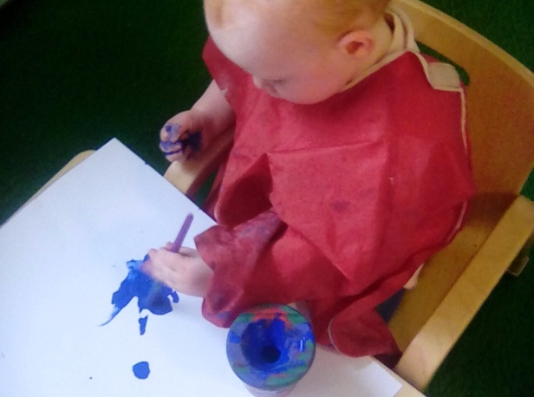
Next month we are going to explore different ice activities, we will add different herbs and essences and hide objects inside the ice for the children to find. We will also be doing some baking with the children to encourage them to mix, pat and roll. This will help the children’s gross motor skills whilst also having lots of fun.
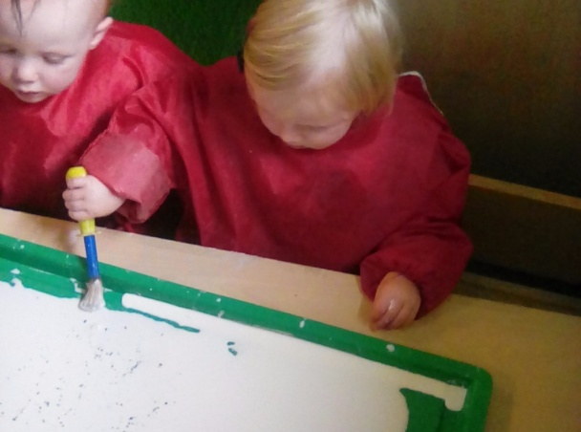
Toddlers
During August our toddlers have been very busy, they have been learning about shapes and colours. The children particularly enjoyed shape printing using a carved out potato. All of the children new the shapes and loved exploring using paint.
Our toddler children have also baking short bread biscuits. They used butter, flour and sugar to create heart shaped biscuits to take home to show their mummies and daddies.
We also enjoyed making a car wash outside, we got a little bit wet but we loved using our sponges, paint brushes and cloths to make our cars nice and shiny.
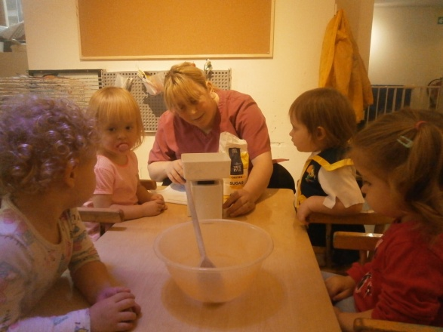
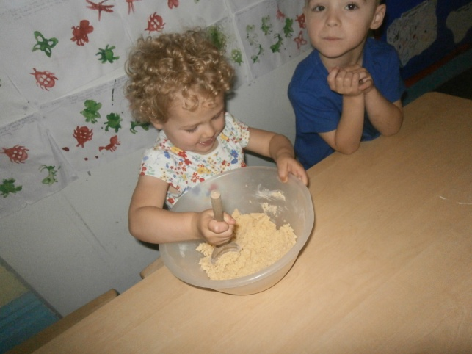
In October we are really looking forward to pets at home coming to visit. We are looking forward to seeing the snake, rabbit, frogs and guinea pigs.
Pre-school
August was a very fun month for pre-school; they went on a fairy hunt in the garden and spo tted a fairy house and some fairy dust next to it. They went onto create lovely fairy pictures and enjoyed dancing like fairies at circle time.
Pre-school also enjoyed making moon sand. They used flour, oil and blue paint that created mouldable sand. The children placed farm animals in it which led to them using their imaginations, telling lots of different stories.
This month we have started our star of the day and star of the week system. Each day/week a child will be given a star badge and certificate to go home, we really want to promote positivity and praise children for all the good work. Look out for their photo’s on the boards. In pre-school we have also started having dinner time helpers, two children each day are chosen to help set up the tables ready for lunch. They help put the cutlery down, put cups and plates out and the children also self serve their dinner. This is to get them ready for school and to help with their gross motor skills. We will be sending home pictures for you to keep!
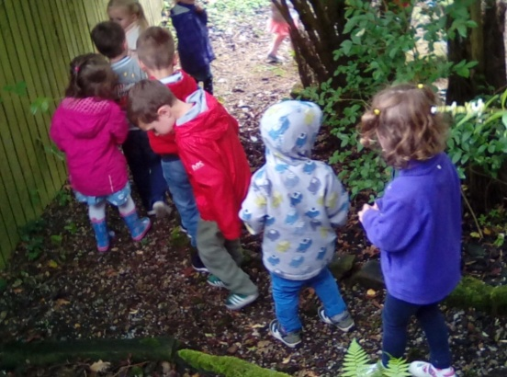
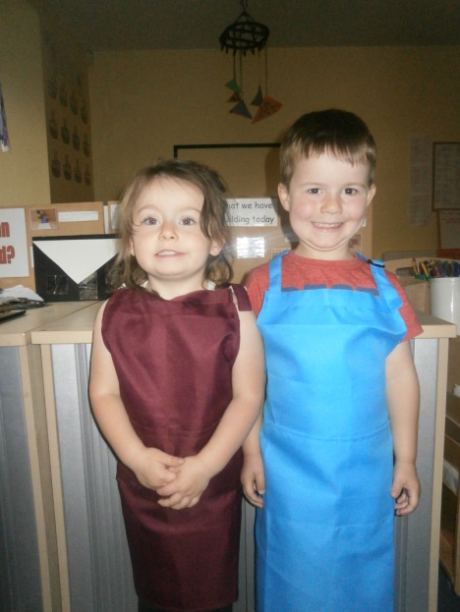
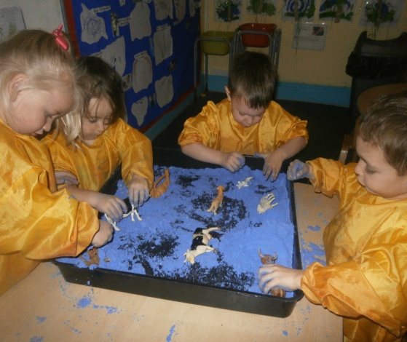
Next month we are also looking forward to our visit from pets at home, we cant wait to see and touch the animals. We will be making pirate hats and going on a treasure hunt outdoors. We are also going to paper mache balloons and make self portraits wit h them.

We hope you like the newsletter,
Many thanks
All staff at Parrock House Nursery

